**Project Introduction/Business Problem:**

The main purpose of this project is to analyze Chicago public schools data and suggest parents of school children better locality and area to look out for housing. Analysis performed includes getting the geocodes of the addresses already present in the dataset using foursquare API. Results from this project helps parents of school children to find better housing area with higher safety and affordable within their requirements.

**Data:**

Dataset with the name Chicago Public schools has got columns like school name, type of school(Elementary, Middle, or High School), street address, city, state and zipcode of schools, school certificate(healthy or not),Safety icon,safety score, average performance of the students, misconduct rate of students, student to teacher ratio, community area name, police distrcit and many other details. I will be not using all the columns for analysis however, only the required columns are retained and unwanted columns will be dropped. During the analysis, address columns are used to generate geocodes using foursquare API and other columns like safety score, healthy_school_certified,misconduct rate of students will be primely considered in order to suggest the best school to the parents. This particular dataset is available online. For convenience, I downloaded the dataset and below is the dataset I imported.

**RESULT**:

Hence from the exploratory data analysis and other analysis conducted,some of the zipcodes of the ares which can be suggested to the parents of school children are 60617 60621 60649 60617 60628 60636 60647 60636 60629 60628 60628 60629 60619 60637 60637 60620 60624 60636 60615

Using foursquare API, restaurants around one of the addresses of one of the zipcode mentioned was plotted. Three restaurants were plotted as shown below.

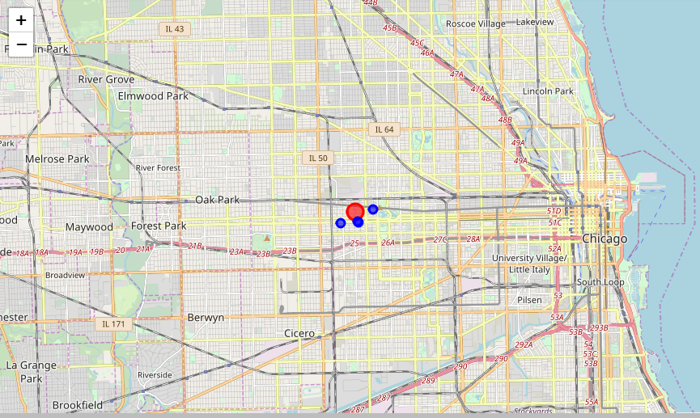

**Conclusion**:

Using Foursquare API, we could find the venues around the addresses of schools having higher safety score. Zipcodes and addresses of the good schools are identified using Data Analysis methods